**SRM INSTITUTE OF SCIENCE AND TECHNOLOGY**

**DEPARTMENT OF COMPUTER SCIENCE AND ENGINEERING**

**KATTANKULATHUR – 603 203**

**15IT304J- Web Programming Register Number: RA1711003011471**

**Name: Manvi Singh Chandel**

**Experiment No: 2**

**Date: 20/08/2020**

**Aim:** **Design a web page with an attractive background color, text color, an Image, font using semantic tags**

**Input:**

<html>

<head>

<style>

.all-browsers {

margin: 0;

padding: 5px;

background-color: orange;

}

.all-browsers > h1, .browser {

margin: 10px;

padding: 5px;

}

.browser {

background: white;

}

.browser > h2, p {

margin: 4px;

font-size: 90%;

}

</style>

</head>

<body>

<article class="all-browsers">

<h1>Most Popular Artists Websites</h1>

<article class="browser">

<h2>April Coppini</h2>

<p>Native New Yorker April is a talented artist who specializes in charcoal drawings. Her subjects of choice are animals, and her work with bees is particularly special. So lifelike are they, in fact, that you almost expect them to fly right off the page.

April’s site is as minimalist as they come, and the home page is nothing more than four words and a small drawing on a stark white background. </p>

</article>

<article class="browser">

<h2>Shantell Martin</h2>

<p>Bridging the gap between fine art and the commercial world, Shantell creates performance art, large scale pieces and clothing designs, to name but a few of her talents. Born in the UK but now living in NYC, and boasting collaboration with Puma and Kendrick Lamar, she is well known for her bold lines and ultra-modern artwork.</p>

</article>

<article class="browser">

<h2>Charles Bongers </h2>

<p>South African Charles is an award winning art director, designer and illustrator. He is also a hugely successful branding artist, and has created work for Microsoft amongst other well-known companies. Charles is known for his strong political views, and his portfolio proves that he’s never afraid to create art which demonstrates those beliefs..</p>

</article>

<article class="browser">

<h2>Rebecca Miller</h2>

<p>Rebecca is an American illustrator with a beautifully clean and simple style. Her work is humorous and is inspired by pop art and graphic novel art. Her fun creations have been featured in exhibitions at Everson Museum of Art and Szozda Gallery, and she is currently working on creating an original graphic novel.</p>

</article>

<article class="browser">

<h2>Julie Bonnemoy</h2>

<p>Julie is a freelance artist and graphic designer working out of Amsterdam and Paris. She’s worked for a host of impressive clients, including Nike and Heineken and is known for her graphical elements mixed with strong, colorful lines. Julie’s talents lie in bringing a product to life, and she uses her creativity to identify what lies at the heart of a brand.

</p>

</article>

</article><h4>Figure Tag</h4>

<figure>

<img src="https://in.pinterest.com/pin/853572935618242218/" alt="Pintura" style="width:100%">

<figcaption>Fig.1 - Trulli, Puglia, Italy.</figcaption>

</figure>

<link rel="stylesheet" href="styles.css">

<link rel="stylesheet" href="https://stackpath.bootstrapcdn.com/bootstrap/4.5.2/css/bootstrap.min.css" integrity="sha384-JcKb8q3iqJ61gNV9KGb8thSsNjpSL0n8PARn9HuZOnIxN0hoP+VmmDGMN5t9UJ0Z" crossorigin="anonymous">

<script src="https://code.jquery.com/jquery-3.5.1.slim.min.js" integrity="sha384-DfXdz2htPH0lsSSs5nCTpuj/zy4C+OGpamoFVy38MVBnE+IbbVYUew+OrCXaRkfj" crossorigin="anonymous"></script>

<script src="https://cdn.jsdelivr.net/npm/popper.js@1.16.1/dist/umd/popper.min.js" integrity="sha384-9/reFTGAW83EW2RDu2S0VKaIzap3H66lZH81PoYlFhbGU+6BZp6G7niu735Sk7lN" crossorigin="anonymous"></script>

<script src="https://stackpath.bootstrapcdn.com/bootstrap/4.5.2/js/bootstrap.min.js" integrity="sha384-B4gt1jrGC7Jh4AgTPSdUtOBvfO8shuf57BaghqFfPlYxofvL8/KUEfYiJOMMV+rV" crossorigin="anonymous"></script>

</head>

<body>

<nav class="navbar navbar-expand-md navbar-dark bg-dark">

<a class="navbar-brand" href="#"> Other Sematics tags</a>

<button class="navbar-toggler" type="button" data-toggle="collapse" data-target="#navbarTogglerDemo01" aria-controls="navbarTogglerDemo01" aria-expanded="false" aria-label="Toggle navigation">

<span class="navbar-toggler-icon"></span>

</button>

<div class="collapse navbar-collapse" id="navbarTogglerDemo01">

<ul class="navbar-nav ml-auto">

<li class="nav-item">

<a class="nav-link" href="#">Home</a>

</li>

<li class="nav-item">

<a class="nav-link" href="#">Content</a>

</li>

<li class="nav-item">

<a class="nav-link" href="#">Contact</a>

</li>

</ul>

</nav>

</body>

<section>

<h4>Section Tag</h4>

<p>A good artist website should showcase your art. Think of how art galleries are designed— they are functional and austere with plenty of whitespace on walls. They do this to get out of the way and showcase the art.</p>

</section>

<hr>

<h4>Video</h4>

<video width="768" height="480" controls>

<source src="sucess.mp4" type="video/mp4">

Your browser does not support the video tag.

</video>

<hr>

<h4>Audio</h4>

<audio controls>

<source src="seeyouagain.mp3" type="audio/mp3">

Your browser does not support the audio element.

</audio>

<hr>

<h4>Aside Tag</h4>

<aside>

<p>Cupick is a place for people to engage with and consume art. It is a platform for visually creative people - painters, illustrators, graphic artists, photographers - to exhibit and monetize their work by selling them as art prints, canvas prints, posters, greeting cards, t-shirts, mugs and other beautiful products. .</p>

</aside>

<p>At Cupick, the philosophy is that 'good art on great products makes the world a better place' and we're on a mission to make consumption of art a daily process.

We want artists to have a great experience using Cupick. A host of features ensure that creating beautiful art remains their focus.</p>

<p>Which includes:- A simple upload tool

- Auto-watermarking, metadata and other download protection tools

- Pricing control: artists decide the value of their work

- Beautiful products: end-to-end managing of sales, production, shipping and customer service by Team Cupick.</p>

<hr>

<footer>

<h4>Footer tag</h4>

<p>Author: Hege Refsnes</p>

<p><a href="mailto:hege@example.com">hege@example.com</a></p>

</footer>

</body>

</html>

**OUTPUT:-**

**OUTPUT:-**

**OUTPUT:-**

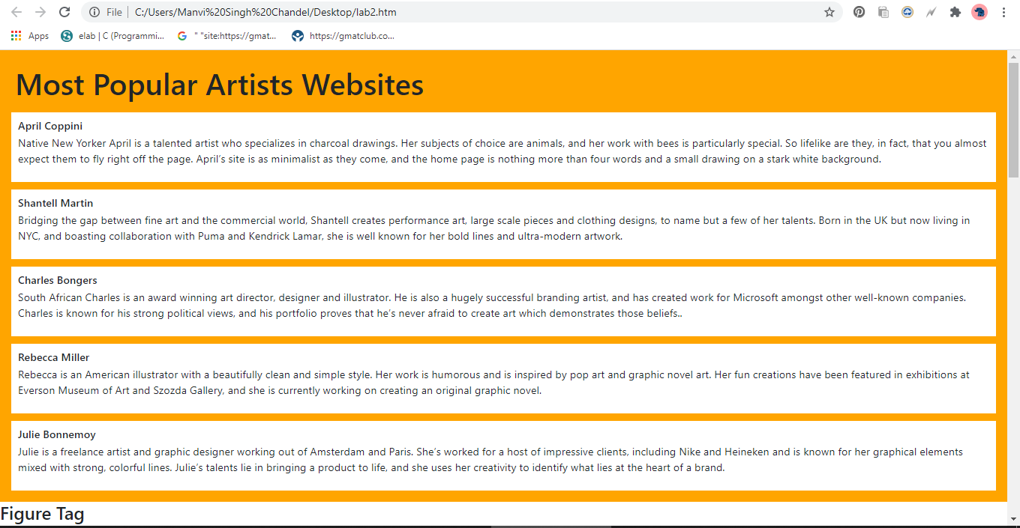

Rest of the screenshots given below

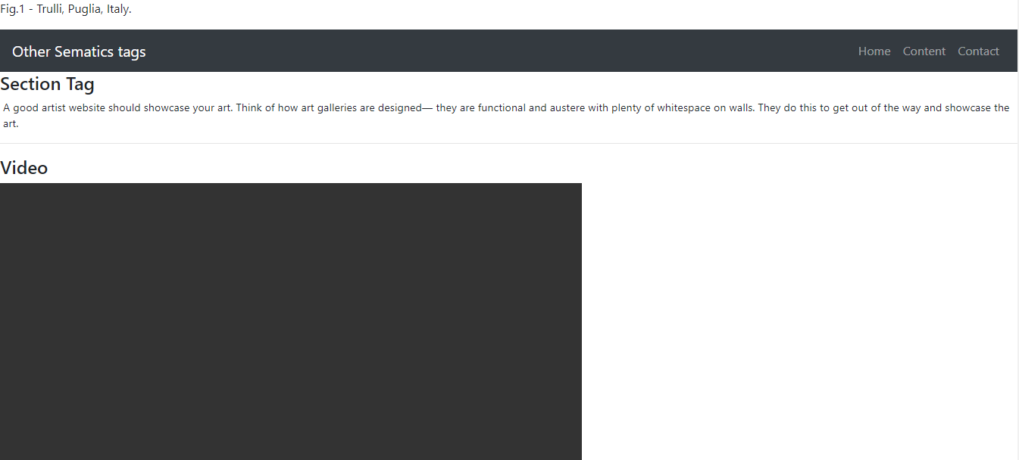

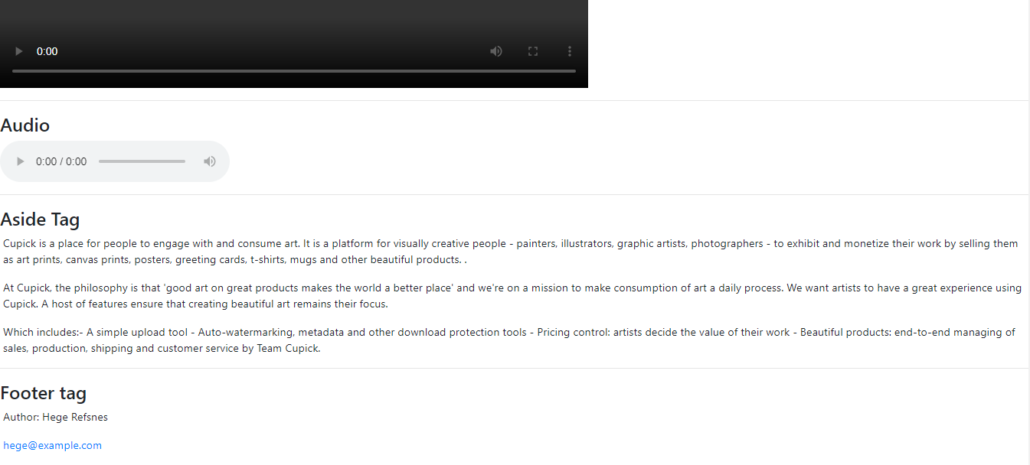

**Result: A webpage using attractive background, text, fonts using structural and semantic tags was created.**